How to help your child with maths at home
Maths learning can happen anywhere.
Maths is all around us and problem solving is at the heart of the mastery approach
Look for maths problems you can solve together, making connections between what your child has been learning at school and the world around them

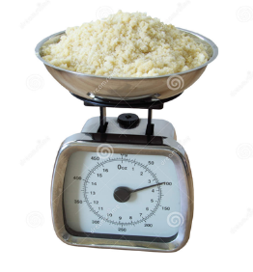
Follow a recipe:
-work together to find out the quantities needed,
-ask your child to weigh the ingredients,
-discuss how you’d halve or double the recipe and discuss the ratio of ingredients.
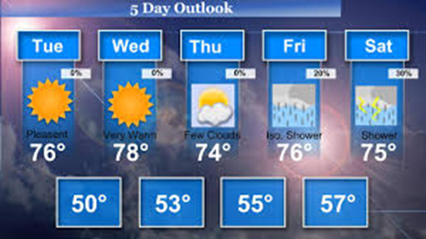
Talk about the weather forecast:
-is today’s temperature higher or lower than yesterday’s?
-What do the numbers mean? - what does minus mean?
Talk about time: -What time do we have breakfast etc -Help your child to learn to tell the time (both digital and analogue).

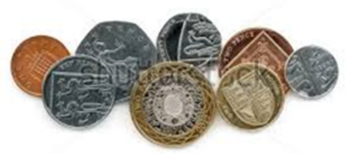
Going Shopping:
-talk about the cost of items and how the cost changes if you buy two items instead of one. - Let your child count out the coins when paying and discuss the change you get back.
-Use coins to explore addition, subtraction, multiplication and division.

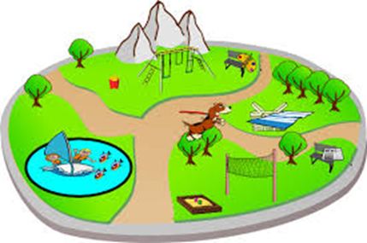
Planning an outing:
-discuss how long it takes to get to the park, and so work out what time you need to leave the house. -What will we need. What will it cost?
-Encourage your child to work out the best solution based on the time and distances.
-Discuss what shapes you see when you get there.

Think and talk like a mathematician
Mathematics language often uses common words in a new way. For example, ‘difference’, ‘right’, ‘product’, ‘table’.
Encourage your child to explain how they have gone about solving a problem,
work with them to test, prove, explain, reflect and spot patterns.
Questions can be powerful tools to boost your child’s thinking: ‘What do you think…?’ ‘Why …?’ ‘What will happen if…?‘Can you see a pattern between…?’ ‘What if we try…?’

And if you want something more formal then…
Number bonds:
-How can you make numbers to 10? (very useful when carrying out mental arithmetic or more formal addition and subtraction)
-To know 3 and 6 makes 9 without having to count on fingers increases speed
- Next, number bonds to 20 then 100.
Multiplication and division facts:
Reception: counting in steps of 10s
Yr1: Count in steps of 2s,5s and 10s
Yr 2: 2, 5 and 10 times tables. Count in steps of 3
Yr 3: 3, 4 and 8 times tables
Yr4: All times tables up to 12x12
Useful apps for your phone/tablet for those odd 5 minutes on the go
-10 minutes a day times tables (Dorling Kindersley)
-Hit the button(Top Marks) Free on PC. £2.99 on phone but worth it
-Old fashioned chanting and quick-fire questions in the car works just as well too but keep it light hearted

Finally: Keep maths fun. Respond to what your children are interested in and want to find out or do.

