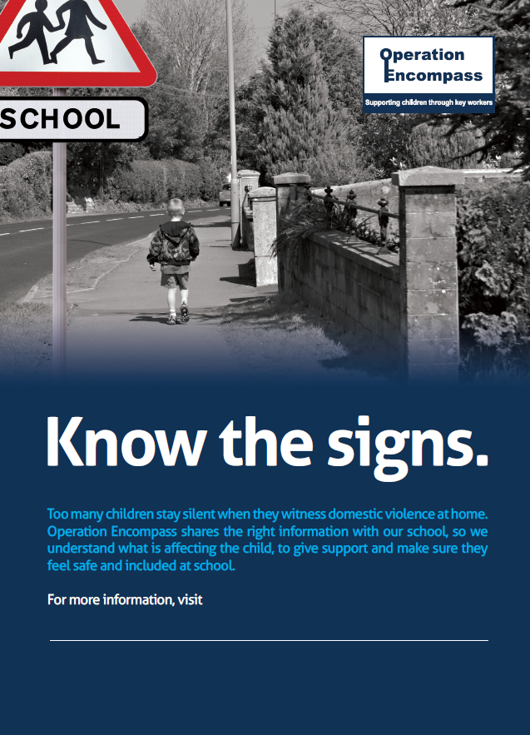

**www.northumberland.gov.uk/Children/Safeguarding/Info.aspx**





